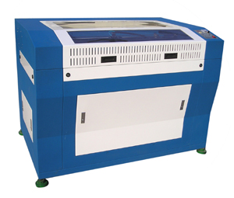

Special Features:

- High speed with low noise

- Compact and efficient structure design

- Adjustable platform easy objects’ loading

- Infrared positioning system with aiming accuracy

- Water fill up alarm and automatic air ventilation device keep good working environment

LD6050/ LD9060 / LD1612 Laser Engraving Machine
 | Laser-Pro Engraver  ·Adopts high quality straight-line guide.  ·Fast and stable three-phase stepping motor  ·High hardness alloy aluminums material with good parallel degree.  ·Constant-current pulse width control circuit with high stability  ·Advanced DSP control technology and SCSI interface  ·Compatible with most sign-making software  ·The lathe type frame guarantees the smoothness  ·Be able to work on varieties of materials | ★Technical Parameters
 |  | Item | LD6050 |  | LD9060 |  |  | LD1612
 |  | Laser Power | 60W |  | 60W / 80W |  |  | 80w
 |  | Max. Working Size | 600×500mm |  | 900x600mm |  |  | 1,600x1,200mm
 |  | Engraving Speed | ≤40m/s
 |  | Laser Type | Co₂ glass laser machine
 |  | Min. Word Model | Chinese characters 2.5mm, English letter 1mm
 |  | Machine Power | <1,500W (without accessory)
 |  | Control Software | Laser Soft V4.0
 |  | Distinguish Precision | 0.025mm
 |  | Orientation Precision | ±0.01mm
 |  | Carve Platform | The electric control platform
 |  | Temperature Request | 5℃～35℃
 |  | Power Supply | 220V/50Hz
 |  | Dimension  (L x W x H)  NET/GROSS WEIGHT | 1,060x700x  1,000mm  126 / 193KG |  |  | 1,430X1,100X  950mm  237 / 322KG |  |  | 2,005x1,620x  1,100mm  400 / 532KG
 |  | Applicable Materials | Rubber plank, organic glass, plastics plank, dual-color plank, leather, artificial leather, cloth, timber, bamboo slice, ceramic, glass, compound crystal, fire-proof plank, cardboard and other nonmetal material. .
 |  | Unit Price(USD) | USD 7.500 | USD 9.000  / 9.800 |  |  | USD 17.000

