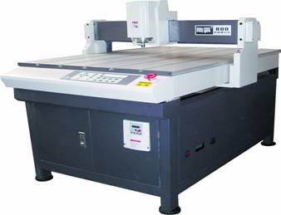
Special Features:

- Linear rail, imported screw bar and track, offers fast and steady movement.

- Numerical-control function offers accurate mill position.

- Back up memory, restart job in the same position after power off.

- Total metal, strong and durable.

DB600/DB800/DB9012 Engraving Machine
 | Fortuna ENG-PRO Engraving Machine ——Middle Size  ·Advanced CNC controller  ·Affordable price for accurate engraving  ·DSP control system can work independently  ·Support for multi-interface operation  ·Imported high precision rolling-pole and guide track  ·Compatible with most sign-making software, good for 3D modeling processing  ·32MB memory buffer, good for high volume production  ·Simulated operation makes it easier to correct mistakes  ·Be able to work on variety of materials  ·LCD display | ★Technical Parameters
 |  | Item |  | DB600 |  | DB800 |  | DB9012
 |  | Working Area |  | 720x890mm |  | 720x1070mm |  | 1020x1482mm
 |  | Max. Engraving Area |  | 600x600mm |  | 600x800mm |  | 898x1210mm
 |  | Speed | Moving | 6.0m/min |  |  |  | 4.5m/min
 |  | Speed | Engraving | 3.0m/min
 |  | Vertical movement |  | 80mm
 |  | Command |  | HPLG3D G-code
 |  | Spindle power |  | 1200W
 |  | Receiver Buffer |  | up to 96 MB
 |  | Resolution |  | 0.005mm |  |  |  | 0.01mm
 |  | Repetition Accuracy |  | 0.05mm
 |  | Rotational of spindle |  | 36000r/min
 |  | Driving system |  | Stepping motor
 |  | Power supply |  | 220V/50Hz
 |  | Net Weight |  | 110kg |  |  | 130kg | 260kg
 |  | Dimension(L x W x H) |  | 1200x980x  1300mm |  |  | 1320x980x  1300mm
 |  | Applicable Materials |  | Plastics, Marble, Aryl, PVC, Board, Copper, Aluminium, Alloy, Perspex ect.
 |  | Unit Price(USD) |  | 8,820 |  |  | 9,180 | 10,260

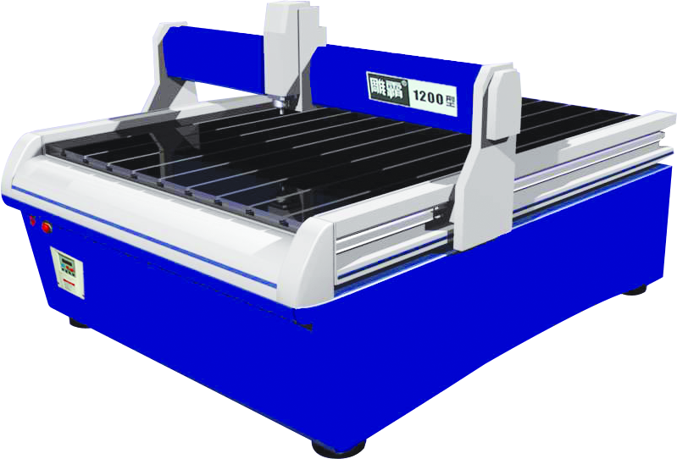
Special Features:

- Linear rail, imported screw bar and track, offers fast and steady movement.

- Numerical-control function offers accurate mill position.

- Back up memory, restart job in the same position after power off.

- Total metal, strong and durable.

DB1200/DB1500/Engraving Machine
 | Fortuna ENG-PRO Engraving Machine ——Large Size  ·Advanced CNC controller  ·Affordable price for accurate engraving  ·DSP control system can work independently  ·Support for multi-interface operation  ·Imported high precision rolling-pole and guide track  ·Compatible with most sign-making software, good for 3D modeling processing  ·32MB memory buffer, good for high volume production  ·Simulated operation makes it easier to correct mistakes  ·Be able to work on variety of materials  ·LCD display | ★Technical Parameters
 |  | Item |  | DB1200 |  | DB1500
 |  | Working Area |  | 1230x1500mm |  | 1230x1800mm
 |  | Max. Engraving Area |  | 1200x1200mm |  | 1200x1500mm
 |  | Speed | Moving | 6.0m/min
 |  | Speed | Engraving | 3.0m/min
 |  | Vertical movement |  | 80mm
 |  | Command |  | HPLG3D G-code
 |  | Spindle power |  | 1500W
 |  | Receiver Buffer |  | up to 96MB
 |  | Resolution |  | 0.005mm
 |  | Repetition Accuracy |  | 0.05mm
 |  | Rotational of spindle |  | 24000r/min
 |  | Driving system |  | Stepping motor
 |  | Power supply |  | 220V/50Hz
 |  | Net Weight |  | 260kg |  | 300kg
 |  | Dimension(L x W x H) |  | 1880x1720x1400mm |  | 2080x1720x1400mm
 |  | Applicable Materials |  | Plastics, Marble, Aryl, PVC, Board, Copper, Aluminium, Alloy, Perspex ect.
 |  | Unit Price(USD) |  | 14,400 |  | 14,760

DB2500/DB3000/Engraving Machine
 | Fortuna ENG-PRO Engraving Machine ——Extra-Large Size  ·Advanced CNC controller  ·Affordable price for accurate engraving  ·DSP control system can work independently  ·Support for multi-interface operation  ·Imported high precision rolling-pole and guide track  ·Compatible with most sign-making software, good for 3D modeling processing  ·32MB memory buffer, good for high volume production  ·Simulated operation makes it easier to correct mistakes  ·Be able to work on variety of materials  ·LCD display | ★Technical Parameters
 |  | Item |  | DB2500 |  | DB3000
 |  | Working Area |  | 1700x3000mm |  | 2340x3400mm
 |  | Max. Engraving Area |  | 1300x2500mm |  | 2060x3000mm
 |  | Speed | Moving | 12.0m/min
 |  | Speed | Engraving | 6.0m/min
 |  | Vertical movement |  | 150mm
 |  | Command |  | HPLG3D G-code
 |  | Spindle power |  | 1500W
 |  | Receiver Buffer |  | up to 96MB
 |  | Resolution |  | 0.01mm |  | 0.0125mm
 |  | Repetition Accuracy |  | 0.05mm
 |  | Rotational of spindle |  | 24000r/min
 |  | Driving system |  | Stepping motor
 |  | Power supply |  | 220V/50Hz
 |  | Net Weight |  | 800kg |  |  | 1000kg
 |  | Dimension(L x W x H) |  | 3200x2160x1780mm |  |  | 3620x2644x1690mm
 |  | Applicable Materials |  | Plastics, Marble, Aryl, PVC, Board, Copper, Aluminium, Alloy, Perspex ect.
 |  | Unit Price(USD) |  | 21,100 |  |  | 31,140
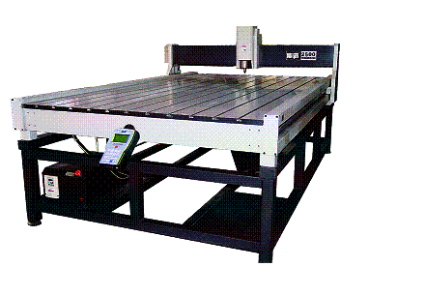

Special Features:

- Imported linear rail, screw bar and track, offers fast and steady movement.

- Numerical-control function offers accurate mill position.

- Back up memory, restart job in the same position after power off.

- Total metal, strong and durable.

